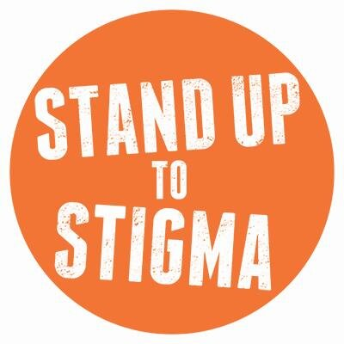
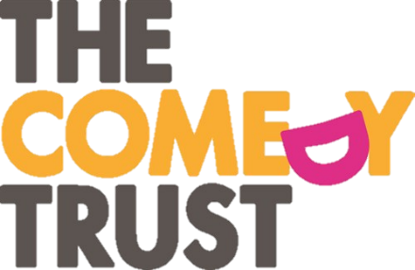

STAND UP

TO STIGMA

In March 2014 The Comedy Trust were successfully awarded a Time To Change* grant to work in partnership with St. Helens Mind, Addaction and St. Helens Council to engage 45 people living with poor mental health in comedy workshops that will:
- improve their confidence and communication skills
- equip them with the skills to write and perform a stand-up comedy routine
- use their creative skills to devise activities to engage the public in meaningful one to one conversation
The project culminated in a series of free comedy events in public libraries and other venues throughout St. Helens where project participants performed to the public and engaged in social contact with audience members in order to challenge the stigma and discrimination associated with mental health.
The Comedy Trust delivered three 6-week comedy workshop programmes working with each of our primary partners as a way to help recruit and engage a diverse selection of participants. Each group will engage 15 participants:
- Addaction – will support workshops for people who are suffering from the effects of alcohol and substance misuse which subsequently has affected their mental health and people who have turned to alcohol and drugs as a result of poor mental health.
- St. Helens Mind – will be the link organisation to promote the workshops to people with mental health issues through their networks and contacts
- St. Helens Council - will be the link organisation to promote workshops to staff within the Local Authority, Housing Association Workforce and general public

Stage One – 6 week course
Each course was designed to use comedy and humour as a vehicle to increase the confidence and self-esteem of participants living with poor mental health, to empower them to speak openly and to connect with people who do not have experience of mental health issues. Stage one aims to combat self-discrimination.
Participants were guided by a creative practitioner and a professional comedian to learn the basics of stand-up comedy and work towards writing and performing their own comedy piece around their own experiences. Routines used comedy to raise awareness and understanding of their condition in a light hearted but supportive way.
Workshops:
- Promoted discussion around discrimination, providing a platform for participants to share experiences
- Promoted friendship and trust
- Enabled participants to use comedy and humour as a coping mechanism
- Improvement of communication skills and body confidence
- Teach participants new skills and help them realise their creative potential
Each participant was also given a wellbeing pack that provided information about support available to them and also a diary where they could log information about how they are feeling throughout the programme and any other information they would like to reflect on.
Stage Two – Public events
Each course culminated in 4 free comedy public performances that took place in community settings around St. Helens with an aim of engaging participants in social contact with members of the public.
Participants from the workshop groups performed and engaged in social contact at four events each. Members of the public were invited to watch participants perform at each event. Events were advertised as simply ‘comedy events’ and not ‘comedy performances by people living with poor mental health’. This was a conscious decision as we preferred that the audience members/library service users have no pre-conceptions or stigmas relating to the participants prior to them attending an event.
When they were not performing, participants were encouraged to engage in meaningful one-to-one conversations, or social-contact, with members of the public. We hoped to attract people who haven’t had any direct experience of mental health issues along to the events, as having one-to-one conversations is one of the most effective ways to help break down stigma and stereotypes that are still associated with mental illness.
Once all of the courses and events concluded a finale event took place at St. Helens Central Library which involved all participants who took part in the project.
TCT and St. Helens Council used their contacts with local celebrities and public figures to champion the project and contribute to the display. This stimulated social contact discussions and provided a platform for thought around the topic of mental health and who it can affect.
Comedy is often seen as one of the most exposing performance disciplines; we believe that engaging people who have lived experience of mental health issues and encouraging them to perform will challenge the public’s misconception and stigma around mental health.

